ORgSys

(Organization Recognition System)

Design Class Collaboration

Collaboration Diagram

Submitted to:

Asst. Prof. Ma. Rowena C. Solamo

Faculty Member

Department of Computer Science

College of Engineering

University of the Philippines, Diliman

Submitted by:

GRANADA, Patrick James B.

MERCADO, Emir R.

YAP, Sharmaine A.

In partial fulfillment of Academic Requirements

Revision Control

*History Revision:*

| Revision Date | Person Responsible | Version  Number | Modification |
| --- | --- | --- | --- |
| 10/19/2013 | Emir Mercado  Patrick Granada | 1.0 | Initial Document |
|  |  |  |  |

*System Name*: ORgSys (Organization Recognition System)

*Description*: The system's purpose is primarily to provide the Office of Student Affairs of UP Diliman's College of Engineering a means of evaluating the organizations during their application period for recognition for the whole school year. This system provides a way for the unit heads to upload the documents submitted by the organizations online. It will also serve as a venue for Associate Dean for Student Affairs and the Review Committee to provide the organizations with the list of required documents requirements for approval and to check if the member roster of the organization is valid.

*Use Case Name:* 1.0 Manage Organizations

*Scenario 1:* Create org account

*Collaboration Diagram:*

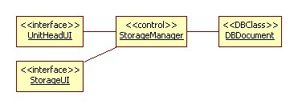

*Scenario 2:* Delete current documents

*Collaboration Diagram:*



*Scenario 3:* Delete documents

*Collaboration Diagram:*

The Online Storage actor is implemented as the StorageManager control class and therefore has no collaboration diagram.

*Scenario 4:* Upload documents

*Collaboration Diagram:*

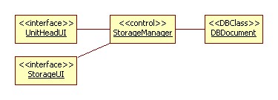

*Scenario 5:* Store documents

*Collaboration Diagram:*

The Online Storage actor is implemented as the StorageManager control class and therefore has no collaboration diagram.

*Use Case Name:* 2.0 Manage Requirements Checklist

*Scenario 1:* Delete old requirements list

*Collaboration Diagram:*

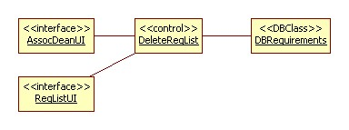

*Scenrario 2:* Create new requirements list

*Collaboration Diagram:*

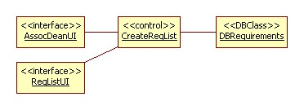

*Scenrario 3:* Finalize requirements list

*Collaboration Diagram:*

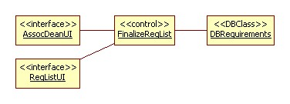

*Use Case Name:* 3.0 Review Orgs for Recognition

*Scenario 1:* Provide Organizations' documents

*Collaboration Diagram:*

The Online Storage actor is implemented as the StorageManager control class and therefore has no collaboration diagram. Moreover, the organizations' documents are already made available in the system thus having no need to provide it.

*Scenario 2:* Upload list of enrolled students

*Collaboration Diagram:*

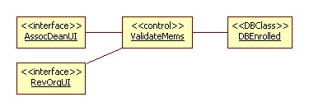

*Scenario 3:* Validate org members

*Collaboration Diagram:*

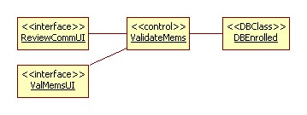

*Scenario 4:* Evaluate submitted documents

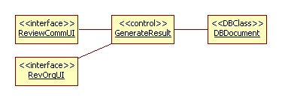

*Collaboration Diagram:*

*Scenario 5:* Finalize list of approved orgs

*Collaboration Diagram:*

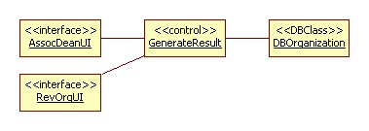

*Use Case Name:* 4.0 View Recognition Status

*Scenario 1:* View org status

*Collaboration Diagram:*

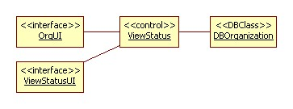

*Scenario 2:* View dept. org status

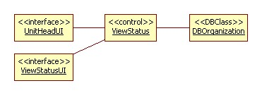

*Collaboration Diagram:*

*Scenario 3:* View all org status

*Collaboration Diagram:*

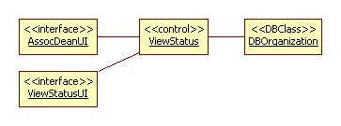

*Use Case Name:* 5.0 View Requirements Checklist

*Scenario 1:* View requirements checklist

*Collaboration Diagram:*

